Vegetation Community Monitoring Protocol for the Heartland Inventory and Monitoring Network

Standard Operating Procedure 6: Measuring Ground Cover

Version 2.00 (2018)

Revision History Log:

| Previous Version # | Revision Date | Author | Changes Made | Reason for Change | New Version # |
| --- | --- | --- | --- | --- | --- |
| 1.00 | 2018 | S. Leis | Improve clarity, add litter depth. Change SOP number. | Increase structural data. | 2.00 |
|  |  |  |  |  |  |
|  |  |  |  |  |  |
|  |  |  |  |  |  |

This SOP gives step-by-step instructions for measuring ground cover in the circular 10 m2 plots (3.57-m diameter). It also explains the procedure for filling in the ground cover section of the Data Form “Ground Flora Data Collection Form” located in SOP 7-Measuring Ground Flora. Refer to SOPs 3-5 (Establishing and Marking Permanent Sample Sites, Documenting Site Disturbance, and Monitoring Site Setup) for details concerning the establishment and set up of the sample unit and the 10 m2 plots, as well as details on the plant species data collected concurrently with the ground cover data.

Equipment List

See equipment list in SOP 3-Establishing and Marking Permanent Sample Sites.

Additional items needed:

* Ground Flora Datasheet, Figure 6.0
* Retractable measuring rod (graduated in cm)

Collecting and Recording Data

1. Ground Cover

Measurement of ground cover attributes of each sample unit describe physical changes resulting from management activities. Estimate ground-level cover of bare soil, bare rock, leaf litter, grass litter, woody debris, and total unvegetated area for each 10-m2 plot. See definitions below for each category. These data will allow for exploration of correlative relationships between compositional changes and environmental attributes.

The percent cover estimations for each ground cover element use the same modified-Daubenmire cover classes as those described for plant species foliar cover estimates described in SOP-7 Measuring Ground Flora (Table 6.0). Areal cover is the measurement for bare soil, bare rock, leaf litter, grass litter, woody debris, and unvegetated cover. However, total unvegetated cover estimates use basal stem cover and not foliar cover. Visual estimates include what can be seen from above without digging through the plant material layers. Example 1: rocks completely covered by litter would not factor into the bare rock estimate; example 2: grass litter and leaf litter may overlap in the plot, and both may be seen simultaneously so both are included in the estimates; example 3: leaf litter below a large, downed tree trunk. Record the woody debris, but not the unseen leaf litter underneath it.

Record ground cover information below the header information of the data sheet used for plant species data (“Ground Flora Datasheet” in SOP 7-Measuring Ground Flora Figure 6.0). Estimate ground cover before species plot data to minimize the trampling effect on ocular estimates.

To read the plot, set up the site as described in SOP 5-Monitoring Site Setup. Then, walk around the outside of the plot to look for the required elements before estimating ground cover. As with plant species cover, the sum of the individual ground cover categories can be greater than the value recorded for the total category “Unvegetated”. Working with a scribe, record the cover estimates. Ground cover categories absent from the plot should be recorded with a 0.

Table 6.0. Modified-Daubenmire cover value scale used to determine unvegetated substrate cover for the HTLN Parks.

| Cover Class Code | Range of Cover (%) | Class Midpoint (%) | Upper Break-point Visual Cue |
| --- | --- | --- | --- |
| 7 | 95.1-100 | 97.5 | 10 m2-hoop full extent (100%) |
| 6 | 75.1-95.0 | 85.0 | Subtract ½ of 1m2-hoop from 10 m2-hoop (95%) |
| 5 | 50.1-75.0 | 62.5 | ¼ sections created by cross-ropes of 10 m2-hoop (75%) |
| 4 | 25.1-50 | 37.5 | ¼ sections created by cross-ropes of 10 m2-hoop (50%) |
| 3 | 5.1-25.0 | 15.0 | ¼ sections created by cross-ropes of 10 m2-hoop (25%) |
| 2 | 1.1-5.0 | 2.5 | ½ of 1 m2-hoop (5%) |
| 1 | present-1.0 | 0.5 | 0.1 m2-hoop (1%) |

Ground Cover Definitions

Several ground cover categories exist for unvegetated substrates. These categories, modified from EPA’s EMAP-SW Streams Field Operations Manual (Peck et. al. unpublished draft), are defined as follows:

* Bare Soil –cover of exposed soil including clay, silt, sand, and well-disintegrated dark duff and humus (see “grass litter” below). Soil surface not covered by litter, plants, or rocks. (Moss is vegetation and therefore that area is not included with bare soil.)
* Rock –aerial cover of exposed loose or fixed rocks >2.54 cm (1 in) in diameter? (USDI National Park Service 2003). Lichen-covered rocks are included in this category.
* Grass Litter – cover of dead grass and grass-like plants (leaf and stem material) no longer standing – should be distinguishable as grass/grass-like plants. There is no concise point at which disintegrated grass litter is considered duff or humus, and thereby included in the ‘bare soil’ category. In making cover estimates for a 10-m2 plot, lightly colored detritus is generally considered grass litter and darker areas as soil. A guideline consistent with this practice is to consider light-colored particles that are otherwise indistinguishable as grass litter and dark colored particles as soil. This does not include leaves from herbaceous broad-leaved plants (aka, forbs).
* Leaf litter – cover of leaf litter from deciduous tree and woody shrub species (examples of woody shrub species include: *Ceanothus* spp., *Cornus drummondii*, *Rhus spp., and* *Symphoricarpos orbiculatus*. This does not include leaves from herbaceous broad-leaved plants (aka, forbs) or coniferous trees. (Note: *Amorpha canescens* is considered a forb.)
* Woody debris – area covered by dead and down woody material regardless of size (i.e. branches, twigs, logs). Only woody debris in contact with the ground are included.
* Unvegetated – 100 minus the total percent basal cover of living plants. Ground cover categories can be >100% because litter types can overlap. Unvegetated cover often has a large value since the stems of herbaceous plants often do not comprise significant basal area. (TIP: Visualize the plot mowed close to the ground leaving only the stems. Then estimate the area the cut stems would take up.)

1. Litter Depth

Litter depth provides additional information about litter that can relate to wildlife habitat, vegetation structure, wildfire fuels, and other ecological effects. For this measurement, all types of litter are included. One litter depth measurement should be collected in each monitoring plot, resulting in 10 measurements/site. The measurement is taken opposite the observing botanist’s nested hoops and within the 10-m2 plot. While the botanist is setting up or reading the smaller hoops, the scribe should take the litter depth measurement. To do so, use the retractable measuring rod, placing it 6-8 inches from the edge of the hoop toward the center of the plot. Gently work the rod through the litter to the soil surface. Avoid disturbing the litter and changing the height of the body of litter. The observer may need to use a finger to create a hole in the litter to feed the rod through. If an obstacle such as a log or stump is in the measuring position, find the nearest area to measure litter. If the desired measuring location is bare rock and bare rocks are rare in the plot (cover class 1 or 2), reposition the rod. But if bare rocks are common (cover class 3 or greater), the observer may accept that location to measure litter depth. Measure the litter depth to the nearest cm. The observer may need to use one hand to create a visual level for the top surface of the litter to the measuring rod, but do not press down on the litter. Do not measure a single piece of litter sticking above the rest, instead measure the average height of the body of litter in front of the rod.

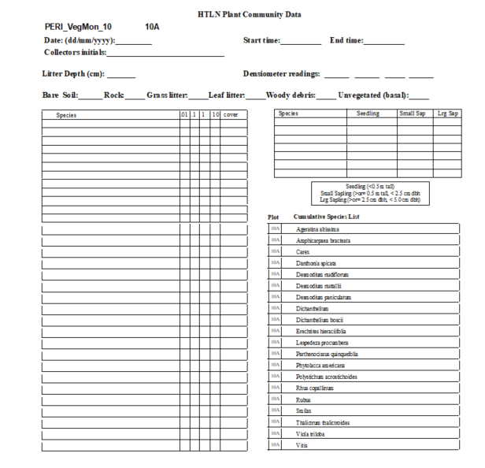

**Figure 6.0.** Plant Community Datasheet, Example for PERI site 10, plot 10A. Ground cover elements are highlighted.

Literature Cited

Peck, D. V., J.M. Lazorchak, and D. J. Klemm (editors). 2001. Unpublished draft. Environmental Monitoring and Assessment Program -Surface Waters: Western Pilot Study Field Operations Manual for Wadeable Streams. EPA/XXX/X-XX/XXXX. U.S. Environmental Protection Agency, Washington, D.C. Accessed from: <https://archive.epa.gov/emap/archive-emap/web/html/fomws.html>.

USDI, National Park Service. 2003. Fire Monitoring Handbook. Boise, ID: Fire Management Program Center, National Interagency Fire Center.